PRESS RELEASE
28 Νοεμβρίου 2023

Harman Kardon sets the rhythm for the 2nd Cyprus Architecture Awards
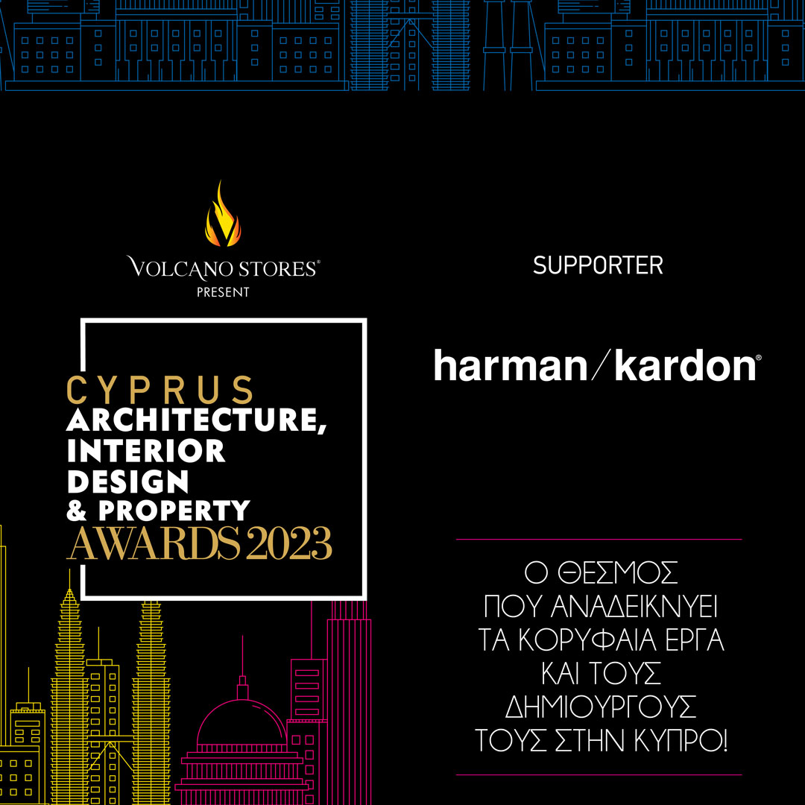
Harman Kardon, the leading high-quality audio company, announces its support for the 2nd Cyprus Architecture Awards. The premier architecture event that highlights outstanding projects and their creators in Cyprus is returning on Tuesday, November 28, at 18:00, at the Municipal Theater of Nicosia, to honor the best in this captivating world.
At the prestigious awards ceremony, within a specially designed space, Harman Kardon will showcase its three new Bluetooth speakers recently launched in Cyprus, elevating the acoustic experience through their innovative and pioneering design!
Harman Kardon's top speakers that further enhance the aesthetics of the event space are:
- The harman/kardon Luna, known for its high-quality sound and minimalist silhouette. With its advanced 2-direction speaker system and integrated software, it ensures exceptional audio clarity, offering 12 hours of continuous music enjoyment.
- The highly anticipated harman/kardon Aura Studio 4 combines exceptional sound with a captivating design, symbolizing intelligent design and performance that transforms the sound experience into art, celebrating the sensory experience.
- The harman/kardon Go + Play 3 returns with a redesigned interior and exterior, maintaining its characteristic semi-circular silhouette. With a battery life of up to 8 hours, it can be taken anywhere using the ergonomic handle made of anodized aluminum.
Certainly, the exceptional harman/kardon Onyx Studio 8 could not be absent from the event, renowned for its distinctive sound and elegant design.
For more information about Harman Kardon, visit its official website at https://www.spartilia.com.cy/ & Harman Kardon - Spartilia, and its social media channels.
Facebook: https://www.facebook.com/harmankardongreece
Instagram: Harman Kardon Greece & Cyprus (@harmankardongreece) | Instagram profile
Linkedin: https://cy.linkedin.com/company/spartilia-s-a

##
About HARMAN KARDON
Harman Kardon creates beautiful sound that speaks to you. The world-renowned audio brand seamlessly blends function and form through the highest sound quality, elegant design and meticulous attention to detail. In 1954, Harman Kardon became the first audio brand to release a compact AM/FM Hi-Fi receiver. For over 65 years, Harman Kardon has been a leading expert in audio engineering and design, capturing ears and hearts. Affirming the brand's design position, the iconic Harman Kardon SoundSticks are part of the permanent collection of the Museum of Modern Art in New York City.

About Spartilia
Spartilia Ltd. is a Distributor, located in Cyprus, offering high end Consumer Electronics, IT & Technology accessories to specialised Retail Chains and Dealers. Today, Spartilia develops on an exclusive basis the Cypriot Market, for major Audio Brands like JBL, harman/kardon, Q Acoustics, Rekkord and Lifestyle Technology Brands like Native Union, LIVALL and Rapoo.

