PRESS RELEASE
27 November 2023
Harman/Kardon reveals the magic of perfect sound through the all-new Aura Studio 4 Bluetooth speaker
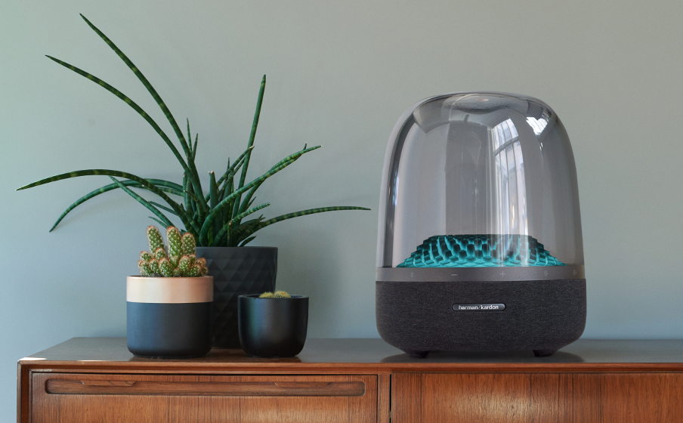
Welcome a new symbol of technological excellence and at the same time a work of modern art. With superb sound, exciting design, innovations that set the tone, create atmosphere and change your mood like never before!
Designed with Harman/Kardon's unparalleled expertise, the new Bluetooth speaker invites listeners to hear music the way it should be heard and experience a multi-sensory, emotion-inducing experience. A stylish speaker that is capable of changing the aura in a room, positively affecting both mood and decor that transforms the space into a living space.
More powerful than its predecessor, the Aura Studio 4 keeps the virtues of the Aura family intact, while at the same time evolving the features that have made it so popular: ultra-fidelity sound, intelligent minimalist design, high build quality. The sound is immersive even at very high volumes (e.g. volume above 80%) and makes you feel like you're in a live performance, as you can enjoy music with crystal clarity and hear in detail the melody each instrument unleashes. Thus, the 130 watts of power is sufficient to enjoy the soundtrack of everyday life in the living room, comfortably covering rooms of up to 20 sq.m. At the same time, the 5.2" inch subwoofer located at the base of the speaker delivers rich and deep bass, while the 6-speaker array guarantees top sound performance in the high notes as well.
Inside, in its transparent dome there is a three-dimensional structure with 324 diamond-like crystals (with lower and higher angles) that synchronize with the music, producing color in 5 different patterns inspired by the magic of nature. Relaxing and lively patterns that allow the coloured light to diffuse in all directions and which can express the mood of the moment or the type of music, depending on the choice the user makes each time.
In addition, the 4th generation Aura Studio embraces the principles of sustainability like no other. Made from 100% recycled polyester yarn, 100% recycled aluminium and 85% recycled plastic, it is a truly environmentally and planet-friendly speaker. Even its paper packaging is FSC certified and its ink is made from soy.
As a result, it is a new icon of modern times that will quickly become your favourite means of expression, entertainment or relaxation and at the same time a statement of style and lifestyle.

More information about the new Harman Kardon Bluetooth speakers at https://www.spartilia.com.cy/, and on the social accounts:
Facebook: https://www.facebook.com/harmankardongreece
Instagram: Harman Kardon Greece & Cyprus (@harmankardongreece) • Instagram photos and videos
Linkedin: https://www.linkedin.com/company/spartilia-s-a?originalSubdomain=cy
##
About HARMAN KARDON
Harman Kardon creates beautiful sound that speaks to you. The world-renowned audio brand seamlessly blends function and form through the highest sound quality, elegant design and meticulous attention to detail. In 1954, Harman Kardon became the first audio brand to release a compact AM/FM Hi-Fi receiver. For over 65 years, Harman Kardon has been a leading expert in audio engineering and design, capturing ears and hearts. Affirming the brand's design position, the iconic Harman Kardon SoundSticks are part of the permanent collection of the Museum of Modern Art in New York City.

About Spartilia
Spartilia Ltd. is a Distributor, located in Cyprus, offering high end Consumer Electronics, IT & Technology accessories to specialised Retail Chains and Dealers. Today, Spartilia develops on an exclusive basis the Cypriot Market, for major Audio Brands like JBL, harman/kardon, Q Acoustics, Rekkord and Lifestyle Technology Brands like Native Union, LIVALL and Rapoo.
Learn more at https://www.spartilia.com.cy/, στο https://www.spartilia.com.cy/brands/harman-kardon/
and our company’s social media
Linkedin
https://www.linkedin.com/company/spartilia-s-a?originalSubdomain=cy

