For more information: Press Release
SPARTILIA S.A For direct publication
Tel.: 35722269410 Date:
Email: sppartners@spartilia.com.cy

Harman Kardon’s cutting-edge speakers stole the spotlight at the Cyprus Architecture Awards, creating a symphony of style and innovation
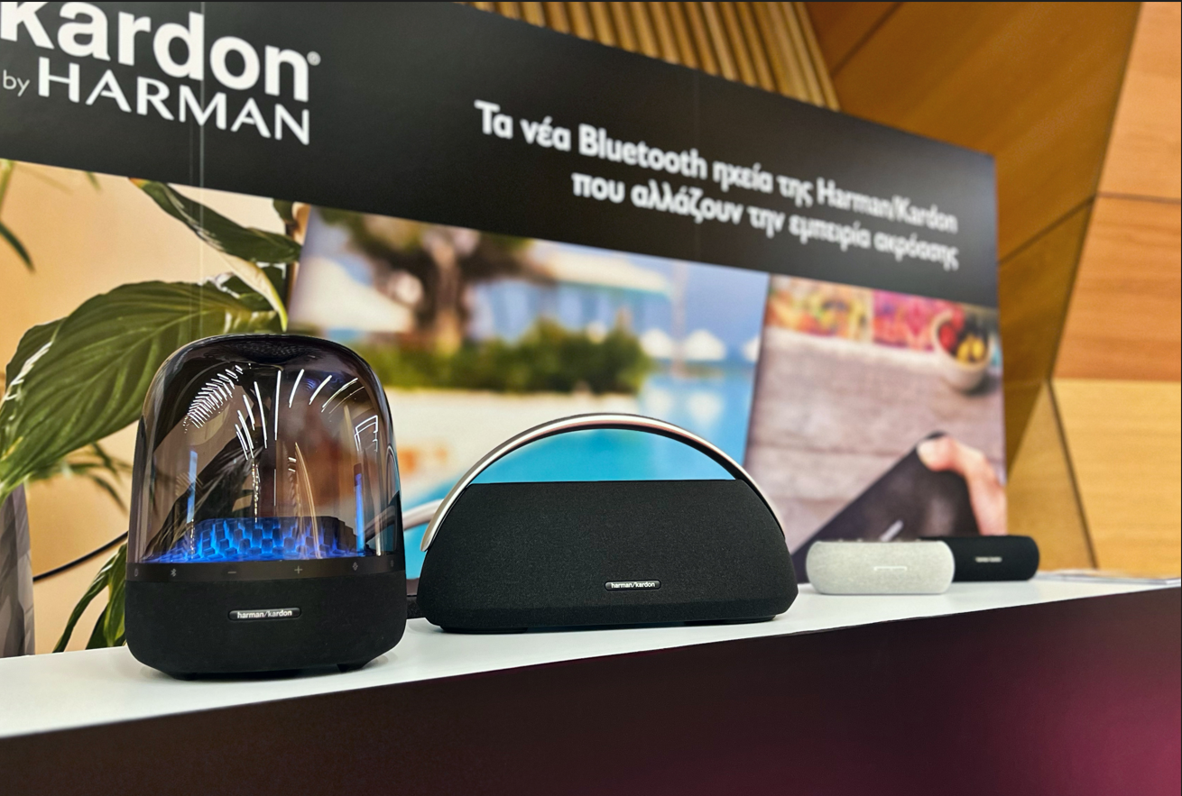
The Cypriot Architecture, Interior Design, and Land Development Awards were successfully completed with great success, with Harman Kardon as a warm supporter. The glamorous ceremony took place last night, during which the top projects and talents in the field of design and architecture were honored.

Harman Kardon made a dynamic presence at the event, contributing to the creation of a unique atmosphere. In the specially arranged space, Harman Kardon provided a distinctive acoustic experience for attendees, showcasing the three new Bluetooth speakers recently released in Cyprus:
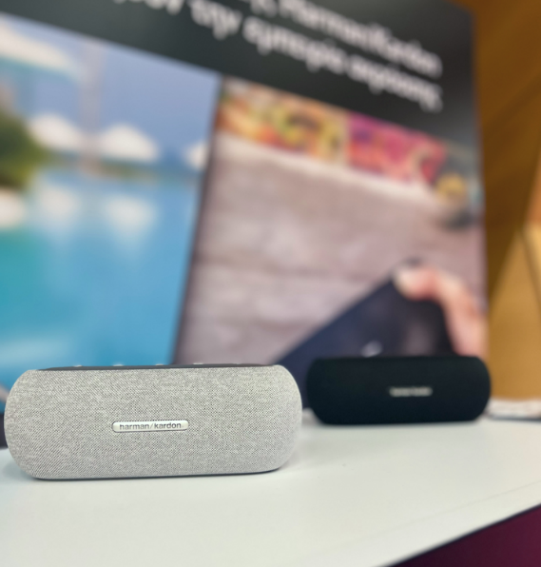
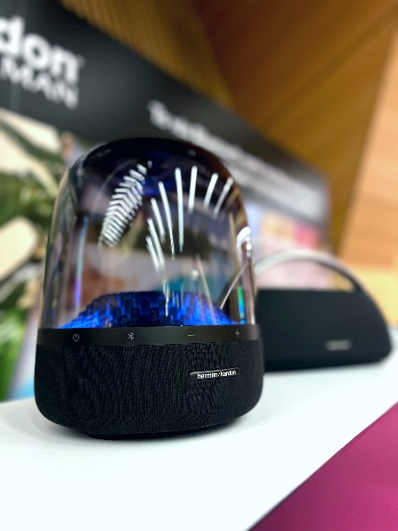

harman/kardon Luna, featuring high-quality sound and a minimalist design, harman/kardon Aura Studio 4 with its exceptional performance and unique design, as well as harman/kardon Go + Play 3 with its refreshed design.

The awards' guests enjoyed the exceptional performance of the speakers, as well as the ergonomic design that incorporates cutting-edge technology. Collaborating with the Cypriot Architecture Awards, Harman Kardon recognized excellence in design and innovation, strengthening the connection between sound and architectural design.
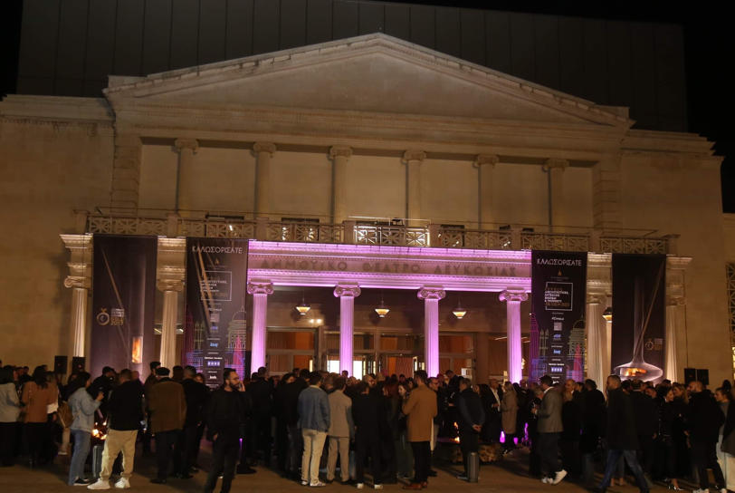

For more information about Harman Kardon, visit our official website on https://www.spartilia.com.cy/ & Harman Kardon - Spartilia and our social media:
Facebook: https://www.facebook.com/harmankardongreece
Instagram: Harman Kardon Greece & Cyprus (@harmankardongreece) | Instagram profile
Linkedin: https://cy.linkedin.com/company/spartilia-s-a

##
About HARMAN KARDON
Harman Kardon creates beautiful sound that speaks to you. The world-renowned audio brand seamlessly blends function and form through the highest sound quality, elegant design and meticulous attention to detail. In 1954, Harman Kardon became the first audio brand to release a compact AM/FM Hi-Fi receiver. For over 65 years, Harman Kardon has been a leading expert in audio engineering and design, capturing ears and hearts. Affirming the brand's design position, the iconic Harman Kardon SoundSticks are part of the permanent collection of the Museum of Modern Art in New York City.

About Spartilia
Spartilia Ltd. is a Distributor, located in Cyprus, offering high end Consumer Electronics, IT & Technology accessories to specialised Retail Chains and Dealers. Today, Spartilia develops on an exclusive basis the Cypriot Market, for major Audio Brands like JBL, harman/kardon, Q Acoustics, Rekkord and Lifestyle Technology Brands like Native Union, LIVALL and Rapoo.

