For more information: Press Release
Spartilia S.A For direct publication
Τηλ.:210-9244505 Hμ.: 13/12/2023
Email: sppartners@spartilia.com.cy

JBL AUTHENTICS:
The new retro speakers with JBL’s rich acoustic just launched!
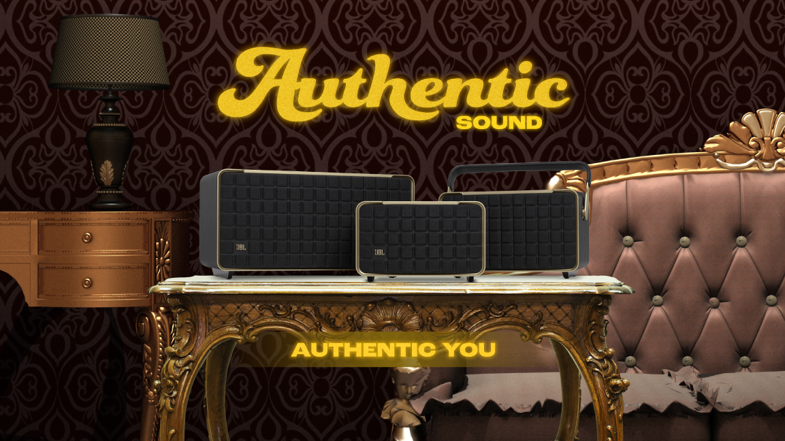

New trio of WiFi speakers brings the power of JBL Signature Sound and the latest tech innovations into the home

Athens, October 2023. – HARMAN International, a wholly-owned subsidiary of Samsung Electronics Co. Ltd., focused on connected technologies for automotive, consumer, and enterprise markets, is once again pushing the envelope of acoustic excellence and iconic design with the launch of the JBL Authentics range of home speakers. Equipped with a host of cutting-edge technologies, Authentics is inspired by JBL's remarkable heritage and the latest consumer trends delivering optimal performance and maximum listening enjoyment.

As a pioneer of cinema, studio, and live concert sound, JBL enjoys an acoustic legacy that is second to none. For more than 75 years, JBL has been amplifying music's power to make listeners feel more connected and more alive. A key player in some of the most iconic events and venues in music history, beloved by professionals for the quality of its sound and by consumers for the immersive thrill its products deliver, JBL has consistently produced groundbreaking technologies that shape the way we listen.

Acoustics excellence with spatial audio powered by JBL & Dolby Atmos®
Among today’s most powerful audio trends is consumers’ desire for sound quality that can provide a true sense of immersion. With JBL Authentics, and more specifically the Authentics 500, JBL leveraged its longstanding partnership with Dolby, integrating their Dolby Atmos encoding standard, which is deployed to deliver immersive audio via one or many speakers. This model also features HARMAN-patented Constant Sound Field technology, combining DSP and a unique acoustic structural design to achieve a wider sound stage and a bigger sweet spot for constant, immersive sound throughout the listening area.

Setting new standards in consumer experience with multi-assistant feature
Voice activation is one of the most popular features in audio devices today, playing an important role in 85% of European homes, according to our survey. JBL Authentics offers a new integration built in collaboration with Amazon and Google that provides customers simultaneous access to their voice assistants on JBL Authentics speakers, allowing customers that choose to register both assistants to communicate with either Google Assistant or Alexa at the same time on the same device. With Google Assistant and Alexa available simultaneously, customers have the choice and flexibility to communicate seamlessly with both voice assistants and take advantage of their different capabilities, and switch between them for different activities. Use either voice assistant to play your favorite music, control your smart home devices, setting timers and alarms, and more, hands-free, using just your voice. Just say “Hey Google,” or “Alexa” to get started.”

Designing Authentics
The Authentics range features discreet echoes of heritage from the retro design era of the 1970s and stunning details that flow from its truly unique history. The phenomenally popular JBL L-100 home speakers inspired the vintage-like design of the Authentics range, while contemporary forms, materials, colors, textures, and finishes were inspired by fashion and lifestyle. The result is a look that seamlessly combines past and future, featuring symbolic elements like the Quadrex grille pattern that helped make JBL L-100 speakers iconic. It is reimagined and extended with softer flowing edges and a subtle convex form that calls to mind the outward push of powerful sound waves. The distinctive JBL PowerLine frame adds an unmistakable touch of quality to the devices. Even the control panel has a satisfying tactile feel. Sustainability is literally built-in to the new Authentics range as well, with cabinets and handles made from recycled aluminum and many internal parts made from recycled plastic.

The key features of Authentic speakers:

AUTHENTICS 200
• Inspired by retro design
• Total power output: 90W
• Simultaneously available Amazon Alexa and Google Assistant
• WiFi & Bluetooth Features

AUTHENTICS 300
• Inspired by retro design
• Battery life: 8 hours
• Simultaneously available Amazon Alexa and Google Assistant
• Total power output: 100W

AUTHENTICS 500
• Inspired by retro design
• Superb sound and performance by Dolby Atmos® Music
• Simultaneously available Amazon Alexa and Google Assistant
• Total power output: 270 Watt

"The JBL Authentics range finds inspiration in JBL’s rich past, revisiting some of its most iconic designs for a new generation of consumers seeking authentic, meaningful experiences. Three years in the making, JBL Authentics does what JBL does best – meet listeners where they are with the superb sound, innovative technologies, and engaging design," said Carsten Olesen, President of Consumer Audio at HARMAN.

For Authentics launch, Spartilia, official distributor of JBL in Greece, created the campaign:
“Authentic Sound, Authentic You”.

The campaign’s message emphasizes to the concept of authenticity as something unique, special and remarkable, all the qualities we found in the JBL Authentics speakers. Everyone is unique and their uniqueness matches with JBL Authentics speakers. Both people and the products they use, rely on authenticity which help them stick out, stand out, and innovate. When everything constantly moves, everything automatically is done and people imitate others, it is really important to search for what’s truly authentic.

Learn more here: https://www.jblgreece.gr/authentics
Instagram: @jbl_greece

Facebook: JBL Greece

About Spartilia
Spartilia Ltd. is a Distributor, located in Cyprus, offering high end Consumer Electronics, IT & Technology accessories to specialised Retail Chains and Dealers. Today, Spartilia develops on an exclusive basis the Cypriot Market, for major Audio Brands like JBL, harman/kardon, Q Acoustics, Rekkord and Lifestyle Technology Brands like Native Union, LIVALL and Rapoo.

About VEESION (www.veesion.gr)
The independent advertising company VEESION was created in 2020 during the lockdown. Open to challenges and collaborations, it is a creative partner to companies in Greece and the United Arab Emirates, offering integrated communication services: Advertising, Branding, Digital & social media, Brand Experience, Video Content, Guerrilla & Growth Hacking Marketing. VEESION constantly invests in talented people with exceptional character, in new technologies and in training. VEESION’s DNA consists of 4 main elements: Innovation, creativity, empathy and efficiency.

About HARMAN
HARMAN (harman.com) designs and engineers connected products and solutions for automakers, consumers, and enterprises worldwide, including connected car systems, audio and visual products, enterprise automation solutions; and services supporting the Internet of Things. With leading brands including AKG®, Harman Kardon®, Infinity®, JBL®, Lexicon®, Mark Levinson® and Revel®, HARMAN is admired by audiophiles, musicians and the entertainment venues where they perform around the world. More than 50 million automobiles on the road today are equipped with HARMAN audio and connected car systems. Our software services power billions of mobile devices and systems that are connected, integrated and secure across all platforms, from work and home to car and mobile. HARMAN has a workforce of approximately 30,000 people across the Americas, Europe, and Asia. In March 2017, HARMAN became a wholly owned subsidiary of Samsung Electronics Co., Ltd…

