Press Release

4 December 2023

**UPGRADE YOUR MODERN LIFESTYLE WITH THE NEW NATIVE UNION LAUNCHES**

*Innovative technological accessories with a minimalist design that meet even your most demanding needs*

With ingenious design, high aesthetics, superior quality and sustainability for a better environment, Native Union, the innovative brand that seamlessly marries fashion with technology, offers revolutionary tech solutions with style for every modern man.

The company's innovative products are once again enriched and Native Union's new launches come to simplify your life, adding a minimalist luxury to your lifestyle in the most unpretentious way.

**Native Union Backback: timeless elegance with respect for the environment**

From business to pleasure, wherever you are, the Native Union Backback in green colour is a bag that will accompany you in all your appearances. Its refined design blends seamlessly with practicality and sustainability, making this bag the ultimate choice . Modern and minimal in design, the **Native Union Backbag** easily pairs with any look and is a safe addition to your wardrobe.

Made from 100% recycled polyester (rPET) derived from plastic bottles, this bag takes care of both you and the environment, demonstrating Native Union's commitment to a greener and more sustainable future. The 20-litre interior is designed to fit your digital lifestyle, as the bag houses a padded laptop sleeve that accommodates devices up to 16", while mesh pockets accommodate your cables, chargers and other everyday essentials.

The key strap, a water bottle holder and a discreet hidden pocket add an extra layer of convenience to your every step and easy access to the items you use most.

The **Native Union Backbag** features a waterproof finish, reinforced stitching, YKK zippers and military grade Cordura fabric where it is most exposed to withstand any harsh conditions. Thick organic cotton straps provide exceptional comfort when using the backpack, while the sturdy top handle provides tote-style versatility.

This bag promises to become one of the must-have items for every traveller, since thanks to the doubling luggage strap, it transforms into a stylish solution for storing your straps during the journey.

**Native Union Case iPhone 15: Protect your device by showing off its great design**

With this Native Union iPhone 15 series case, your device will remain perfectly protected from damage. Made from 100% recycled PCTG & TPU, it is both eco-friendly and stylish. Lightweight and slim, this case allows you to handle your device with ease. It has a special coating for scratch resistance and also to protect against yellowing over time.

The transparent finish of the Native Union Case iPhone 15 highlights the modern and elegant design of your device, while its raised edges offer carefree transportation with drop protection up to 3 meters (10ft), thanks to its sturdy construction. The case is fully compatible with MagSafe charging and accessories, ensuring a seamless experience for technology enthusiasts.

**Strap for Apple Watch: Comfort, durability and stability**

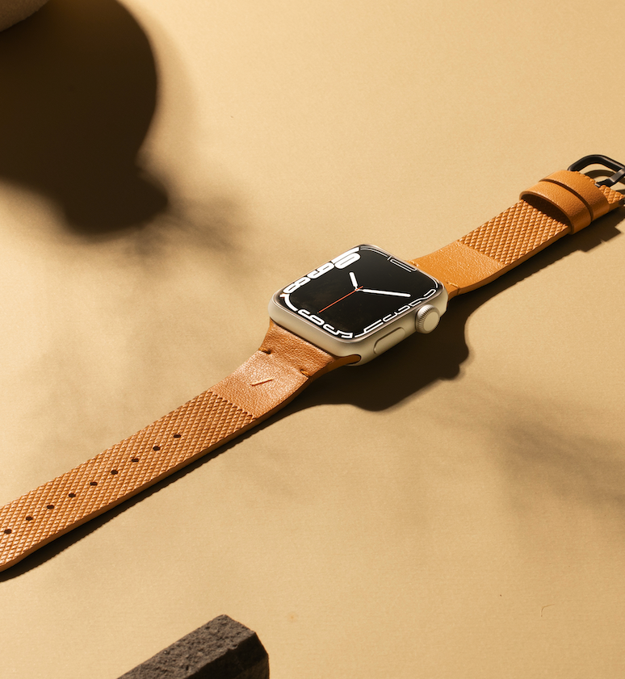

Let time fly and enjoy every moment by pairing your favorite gadget with the Strap for Apple Watch by Native Union, a modern and classic addition that will offer you a comfortable fit, stability and beautiful style. Made with Yatay™ by Coronet, a premium and durable plant material from Italy and with a dual design that gives it a distinctive finish, this strap is both eco-friendly and luxurious. It features protrusions that allow for secure fastening and a soft underlay for a comfortable fit on the wrist all day long.

Change the style of your watch by choosing one of three colours created by Native Union, so every Apple Watch is unique and reflects your personality.

**Magnetic 3-IN-1 Wireless Charger Stand: Charging that catches the eye**

Upgrade the way you charge your phone device and your favorite accessories with **Native Union's Magnetic 3-IN-1 Wireless Charger Stand**. The latest and most modern way to simultaneously charge your iPhone 12 and later, AirPods and Apple Watch, wirelessly.

The sleek, black **Magnetic 3-IN-1 Wireless Charger Stand** is compatible with magnetic alignment to place your iPhone horizontally or vertically while you charge other devices via the USB-C port. It also comes with a removable Apple Watch charging case, or you can plug in another cable for charging up to 15W..

Its weighted base allows easy one-handed disconnection of your devices and accessories for a seamless and hassle-free tech experience.

**Belt Cable Universal 3in1, USB A to MicroUSB-Lightning-USB C: Strength and flexibility**

Charge the batteries of all your devices and accessories with **Native Union's Belt Cable Universal 3in1**, USB A to MicroUSB-Lightning-USB C, without adapter. This ingenious cable offers multiple charging options to any user, with no tangles, thanks to the leather strap. At two meters long, the Belt Cable Universal 3in1, USB A to MicroUSB-Lightning-USB C ensures seamless access to charging, while the nylon-reinforced mesh from the strap makes it resistant to wear and tear over time.

**Drop Wireless Charger with Fabric: Functional and sophisticated charging**

Introduce a new era of charging to your everyday tech life with **Native Union's Drop Wireless Charger with Fabric**. This wireless charger is a modern and innovative design statement. Providing fast operation and use, it is compatible with AirPods up to 5W, iPhone up to 7.5W & other Qi-compatible devices up to 10W.

The **Drop Wireless Charger with Fabric** is constructed with a weighted aluminum base and fabric, and features a non-slip silicone tread that keeps your device in place.

Foreign object detection and thermal protection ensure a safe charging, and it comes with a 2m USB-A to USB-C cable. The Drop Wireless Charger with Fabric is the perfect gift for technology enthusiasts.

**Rise Laptop Stand: Work from the top**

Give your productive hours of the day the ultimate sense of comfort with **Native Union's Rise Laptop Stand.** This folding laptop stand creates the perfect mobile workstation wherever you are. Lightweight and slim in design, made from premium materials, it elevates your Macbook at an angle of up to 20° for the best possible restful posture and maximum comfort.

**Native Union fast Gan Charger PD 67W with travel Adapter: Unlock the power of fast charging**

Discover the fast charging capabilities of up to 2 devices simultaneously with 2 USB-C ports with **Native Union's Fast Gan Charger PD 67W** with travel adapter. Unlock power delivery for laptops, tablets, phones and other favorite accessories. Dynamic power distribution automatically optimizes power distribution between your devices. The 67W PD-capable USB-C port supports full-speed charging for your 14″ MacBook Pro or powers your iPhone up to 50% in less than 30 minutes.

**Native Union** continues to redefine the fashion of technology, seamlessly bridging style, functionality and sustainability. With a firm commitment to minimizing their environmental footprint, Native Union invites you to explore the next generation of tech accessories.

##

**About NATIVE UNION**

The company’s history essentially begins with the release of the first iPhone in 2007. This event inspired CEO and co-founder, Igor Duc, to start NATIVE UNION. He knew it would change the way we live. Its first product, the Pop Phone Retro Handset, was designed for a more tangible and easy experience when making calls. Over a decade and many gadgets later, she now has offices in Los Angeles, Hong Kong, Paris and a presence in every corner of the globe. In Cyprus it is represented by Spartilia and through them it is distributed to a wide network of resellers (major technology chains, premium retailers and e-shops).

**About Spartilia**

Spartilia Ltd. is a Distributor, located in Cyprus, offering high end Consumer Electronics, IT & Technology accessories to specialised Retail Chains and Dealers. Today, Spartilia develops on an exclusive basis the Cypriot Market, for major Audio Brands like JBL, harman/kardon, Q Acoustics, Rekkord and Lifestyle Technology Brands like Native Union, LIVALL and Rapoo.

Learn more at <https://www.spartilia.com.cy/>, <https://www.spartilia.com.cy/brands/native-union/>  
and the company's Social Media

**Facebook** <https://www.facebook.com/nativeuniongrcy>  
**Instagram** <https://www.instagram.com/nativeuniongrcy/>

**Linkedin** <https://www.linkedin.com/company/spartilia-s-a/?originalSubdomain=cy>