PRESS RELEASE
20 Δεκεμβρίου 2023
‘TIS THE SEASON FOR DIVINE SOUND: WELCOME NEW YEAR WITH GREAT GIFTS FROM HARMAN KARDON THAT ELEVATE YOUR AUDIO EXPERIENCE
Harman/Kardon's Aura Studio 4, Go + Play 3, Luna and Onyx Studio 8 Bluetooth speakers promise to delight music lovers with their unbeatable sound accuracy and sleek, modern yet minimalist silhouette that fits in any space.

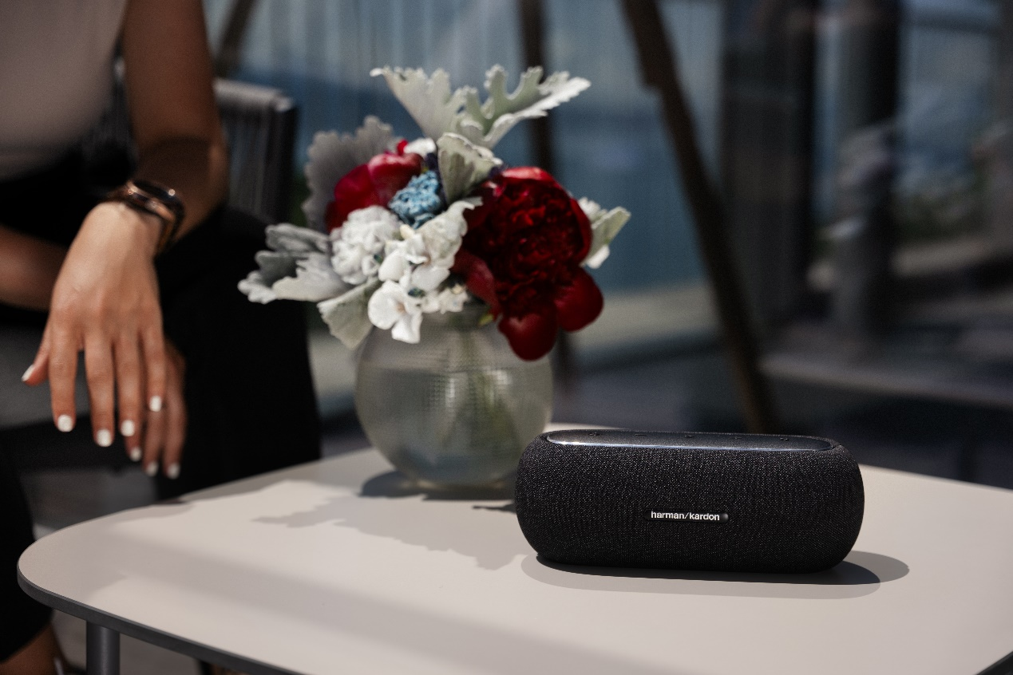
Music is more than just entertainment; it is a passion that resonates deep within the soul. This holiday season, give the ultimate tech gift to your loved ones who live every moment of their life in the company of melodies, by choosing one of four new Harman/Kardon products.
The world-renowned brand's new portable speakers elevate every musical journey, taking sound quality to another level, enriching the listening experience with their dynamism and innovative construction, while at the same time constituting a visual intervention in the space by offering a rich visual ambience.

Get your loved ones in the mood for the holidays with the Harman/Kardon Luna, an elegant Bluetooth speaker, perfect for both indoor and outdoor use. Dynamic and high-quality sound that gives a realistic character to everything it plays, minimalist, ergonomic design, slim silhouette, and waterproof certification are the elements that make it so special and unique. Thanks to the advanced 2-way speaker system and the software it incorporates, it ensures excellent sound clarity offering 12 hours of continuous and enjoyable listening.
The Harman/Kardon Luna is ideal for relaxing while enjoying breakfast in the kitchen or for creating the perfect Christmas atmosphere next to your fireplace. The rugged construction with a premium fabric casing and anodized aluminum top, waterproof and dust-resistant construction make it even more sought-after.
Organise an unforgettable party for your friends or family during Christmas season by adding the Harman/Kardon Aura Studio 4 to your guest list. Its mesmerising lights dance to the rhythm of its high-quality sound, while its iconic 324-crystal transparent dome emits an enchanting diamond pattern that shines in all directions as it syncs with the music. Made largely from recycled materials, it is also a statement of sustainability inspired by Nature.
Indulge in the magic of the holidays by pressing play on Harman/Kardon's Go + Play 3 luxury portable speaker. It's not just another audio device, but a masterpiece that features crystal-clear, high-performance 3-way stereo sound. Give it as a gift and encourage your friends to place it on a coffee table in their living room.
The Go + Play 3 portable speaker, which has returned dynamically redesigned inside and out, while retaining its characteristic semi-circular silhouette, will "dress" the room with powerful sound vibes, while the new subwoofer with its loudspeaker facing downwards will fill it with bass. What also makes it a top choice is its long battery life (up to 8 hours) and its ergonomic anodised aluminium handle, which offers the possibility of moving it anywhere easily and unhindered.
Last but not least, for the music lovers, those who love to spend their free time listening to podcasts or those who appreciate high aesthetics, you can choose the new Harman Kardon portable speaker system, Onyx Studio 8, which is a great artistic statement in itself.
With iconic and stylish design, made of high quality eco-friendly materials, the Onyx Studio 8 will beautifully decorate any home and change the standard of every recipient's listening experience, offering rich, clear and harmonious sound.

The fabric covering the body of the speaker is made from recycled polyester yarn and the packaging is fully compliant with FSC requirements. The acoustic part of the speaker includes a 120 mm main speaker and two 20 mm tweeters, for incredible stereo performance.
The slim, anodised aluminium handle, which also serves as a sturdy base, offers easy portability. When switched on, Onyx Studio 8 automatically calibrates itself to the environment, ensuring the best possible sound wherever it is placed.
With an 8-hour battery life, it can go wherever the music leads, create the most beautiful soundscape for any occasion, while seamlessly connecting to any Bluetooth device for enhanced, exceptional sound.

More information about the new Harman Kardon Bluetooth speakers at https://www.spartilia.com.cy/, and on the social accounts:
Facebook: https://www.facebook.com/harmankardongreece
Instagram: https://www.instagram.com/harmankardongreece/
Linkedin: https://cy.linkedin.com/company/spartilia
##
About HARMAN KARDON
Harman Kardon creates beautiful sound that speaks to you. The world-renowned audio brand seamlessly blends function and form through the highest sound quality, elegant design and meticulous attention to detail. In 1954, Harman Kardon became the first audio brand to release a compact AM/FM Hi-Fi receiver. For over 65 years, Harman Kardon has been a leading expert in audio engineering and design, capturing ears and hearts. Affirming the brand's design position, the iconic Harman Kardon SoundSticks are part of the permanent collection of the Museum of Modern Art in New York City.

About Spartilia
Spartilia Ltd. is a Distributor, located in Cyprus, offering high end Consumer Electronics, IT & Technology accessories to specialised Retail Chains and Dealers. Today, Spartilia develops on an exclusive basis the Cypriot Market, for major Audio Brands like JBL, harman/kardon, Q Acoustics, Rekkord and Lifestyle Technology Brands like Native Union, LIVALL and Rapoo.

