For more information: Press Release
OFFICIAL DISTRIBUTOR SPARTILIA S.A For direct publication
Τηλ.: 35722269410 Hμ.: 12/02/2024
Email: sppartners@spartilia.com.cy

JBL Snow Party returns for 2024 with Martin Garrix and Tigerlily on the stage!

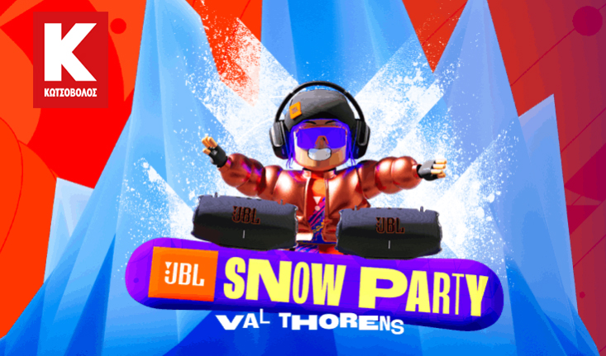
3 days at a ski resort, VIP parties and live performances at the most disruptive event of the winter. Get the chance to be in Val Thorens in the French Alps, at the biggest Snow Party ever, by buying a JBL product from Kotsovolos.

JBL Cyprus (Official Distributors: Spartilia S.A.) announces a contest for buyers of JBL products for another year in a row. Buy a JBL product from Kotsovolos stores or e-shops in Greece and Cyprus and enter the contest to win tickets to the biggest Snow Party in the Alps ever!

The participation period starts at 02/01/2024 and ends on 26/02/2024. To participate, buy JBL products from stores or e-shops of Kotsovolos Greece & Cyprus during the participation period and enter the contest by filling in your details (Name, Telephone, Email Address and the store where you bought it) on this website https://eu.jbl.com/snowparty-2024-gr.html.
*please keep the receipt

Welcome to JBL Snow Party
Get ready for the ultimate Snow Party experience, on and off the stage. Board a round-trip flight and follow JBL to the all-inclusive resort of Val Thorens, with ski-to-door access, stunning mountain views and a unique Club Med dining experience.

Val Thorens is located in the Savoie region of France and is Europe's highest ski-resort, bringing in fresh snow from November to May.



Enjoy unique winter activities.
Bring your sense of adventure to the mountain and engage in sports and winter activities that the peaks offer. Hit the slopes with confidence - with routes for experienced and beginners alike - or get ready for sledding, climbing and, of course, the ultimate apres-ski party.

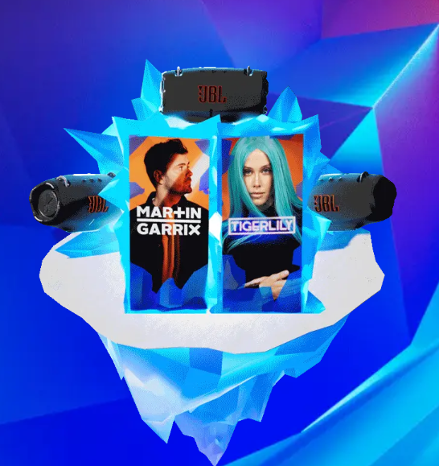
Experience the ultimate party!
Enjoy another day on the slopes and get ready for an evening of incredible rhythm. Join us at the JBL Altitude Party and keep dancing at the Après Ski Party to the beats of Tigerlily and Martin Garrix!

Relax at the hotel before returning home. Come back with amazing memories and epic photos for your friends on Social media.

Join us at the 5th annual JBL Snow Party for a weekend full of snow, music, sports and many more!

Find out more here:
JBL Snow Party 2024
JBL Snow Party 2024 | ΚΩΤΣΟΒΟΛΟΣ - kotsovolos.gr

About Spartilia
Spartilia Ltd. is a Distributor, located in Cyprus, offering high end Consumer Electronics, IT & Technology accessories to specialised Retail Chains and Dealers. Today, Spartilia develops on an exclusive basis the Cypriot Market, for major Audio Brands like JBL, harman/kardon, Q Acoustics, Rekkord and Lifestyle Technology Brands like Native Union, LIVALL and Rapoo.

About HARMAN
HARMAN (harman.com) designs and engineers connected products and solutions for automakers, consumers, and enterprises worldwide, including connected car systems, audio and visual products, enterprise automation solutions; and services supporting the Internet of Things. With leading brands including AKG®, Harman Kardon®, Infinity®, JBL®, Lexicon®, Mark Levinson® and Revel®, HARMAN is admired by audiophiles, musicians and the entertainment venues where they perform around the world. More than 50 million automobiles on the road today are equipped with HARMAN audio and connected car systems. Our software services power billions of mobile devices and systems that are connected, integrated and secure across all platforms, from work and home to car and mobile. HARMAN has a workforce of approximately 30,000 people across the Americas, Europe, and Asia. In March 2017, HARMAN became a wholly owned subsidiary of Samsung Electronics Co., Ltd…

