PRESS RELEASE
6 Μαρτίου 2024

Harman/Kardon Luna:
On Women's Day, Aesthetics Meet Acoustic Precision
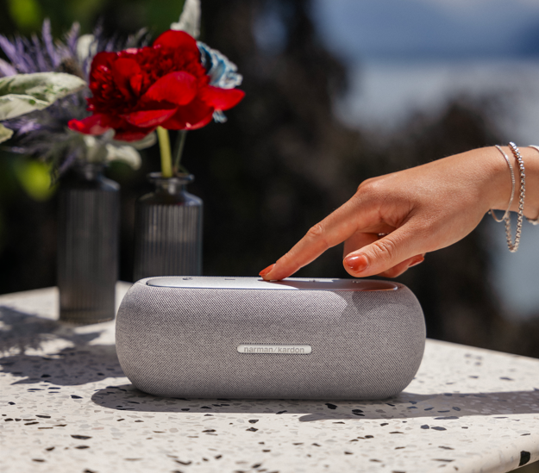
On the anniversary of International Women's Day, Harman/Kardon invites you to discover a unique level of audio enjoyment with the Luna Bluetooth speaker. Combining aesthetics with technology, the Harman/Kardon Luna elevates sound into a refined experience.

The Harman/Kardon Luna Bluetooth speaker seamlessly integrates into any setting with its elegant and minimalist silhouette while delivering beautiful Harman/Kardon sound. The soft-touch fabric housing and anodized aluminium top panel not only look refined but also feel great in your hand. The ultra-portable, ergonomic design is perfect for carrying from room to room and even outdoors.
Experience balanced, high-quality audio in a compact form like never before with Harman/Kardon Luna's advanced 2-way speaker system. Advanced drivers deliver Iconic Harman/Kardon sound with exceptional clarity, ensuring you hear every detail. Pair two speakers together for a true stereo experience with a wider soundstage.
With up to 12 hours of built-in battery life, Harman/Kardon Luna is the perfect all-day companion to power your personal soundtrack. And with its IP67 dustproof and waterproof rating, the speaker can withstand accidental spills, rain, or even a quick dip in the pool.
Last but not least, the speaker grille fabric is woven from 100% recycled polyester yarn, 85% post-consumer recycled plastic is used in the frame, and the top panel is made from 50% recycled aluminium. It is also packaged in FSC-certified paper printed with soy ink, and the battery is replaceable at designated repair centers.
Harman/Kardon celebrates the strength, intelligence, and dedication of every woman this International Women's Day, providing the perfect acoustic companion for every moment of life.

More information about the new Harman Kardon Bluetooth speakers at https://www.spartilia.com.cy/, and on the social accounts:
Facebook: https://www.facebook.com/harmankardongreece
Instagram: https://www.instagram.com/harmankardongreece/
Linkedin: https://cy.linkedin.com/company/spartilia

About HARMAN KARDON
Harman Kardon creates beautiful sound that speaks to you. The world-renowned audio brand seamlessly blends function and form through the highest sound quality, elegant design and meticulous attention to detail. In 1954, Harman Kardon became the first audio brand to release a compact AM/FM Hi-Fi receiver. For over 65 years, Harman Kardon has been a leading expert in audio engineering and design, capturing ears and hearts. Affirming the brand's design position, the iconic Harman Kardon SoundSticks are part of the permanent collection of the Museum of Modern Art in New York City.

About Spartilia
Spartilia Ltd. is a Distributor, located in Cyprus, offering high end Consumer Electronics, IT & Technology accessories to specialised Retail Chains and Dealers. Today, Spartilia develops on an exclusive basis the Cypriot Market, for major Audio Brands like JBL, harman/kardon, Q Acoustics, Rekkord and Lifestyle Technology Brands like Native Union, LIVALL and Rapoo.

