**For more information: Press Release**

**OFFICIAL DISTRIBUTOR SPARTILIA S.A** For direct publication

Τηλ.: 357 222694 10 Date: 20/05/2025

Email: : [sppartners@spartilia.com.cy](mailto:sppartners@spartilia.com.cy)

**Spartilia brings new air to Cyprus - The premium Dutch brand Duux now available in Cyprus**

Athens – May 20th, 2025 – Spartilia S.A. introduces Duux, the leading Dutch brand that combines 20 years of expertise in air technology with minimal design, is officially available in Cyprus.

With a name derived from the words Dutch and Luxury, Duux offers a complete range of products for purifying and controlling indoor air: from air purifiers, humidifiers and dehumidifiers to portable air conditioners, fans and heaters . Each product is designed to enhance the quality of life, boosting health and well-being in our daily lives.

**Clean air is a need - not a luxury**

We breathe 20,000 times a day, up to 10,000 litres of air, yet we spend 90% of our time indoors, where air quality is on average five times worse than outside. Duux is responding to this need with high performance products that improve the microclimate of every home in a simple, quiet and unobtrusive way.

**Designed for better air – when technology meets design**

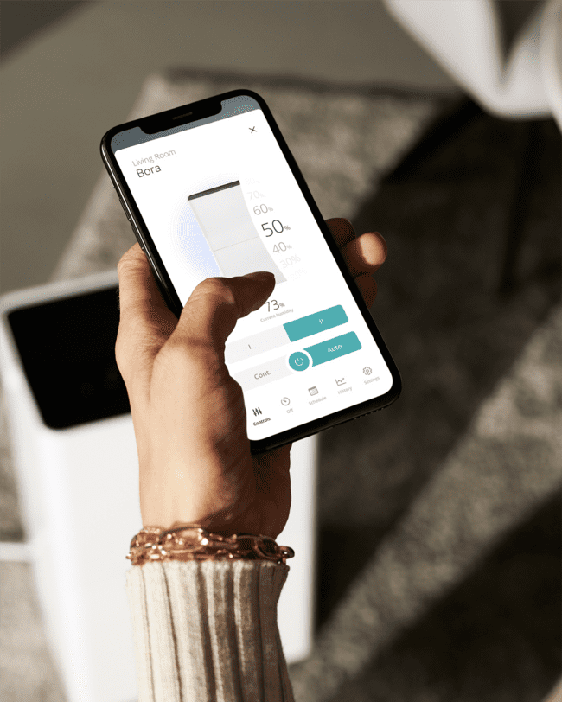

Duux products promise top performance without compromising on aesthetics. With a clean, Dutch design and minimal lines, they blend discreetly into any space, and their operation is virtually silent. At the same time, Duux offers the ultimate smart experience: thanks to the Duux App and the possibility for voice commands, users can control their home environment from anywhere with their mobile phone or voice.

**Innovation with respect for the environment**

At Duux, sustainability is not just a trend - it's a commitment. Every product is designed with long-term use, repairability and responsible consumption in mind. Packaging has been redesigned to reduce the environmental footprint by reducing materials and optimizing volume. In addition, Duux is investing in creating products that consume less energy without compromising performance, encouraging responsible use by consumers.

Spartilia S.A. distributes Duux in Cyprus. Discover the full range of products and experience the difference of a space with a different air - all year round.

For more information, visit [Duux](https://duux.com/el/) website.

Find Duux on [social media](https://www.instagram.com/duux_gr_cy/).

**About Spartilia**

Spartilia Ltd. is a Distributor, located in Cyprus, offering high end Consumer Electronics, IT & Technology accessories to specialised Retail Chains and Dealers. Today, Spartilia develops on an exclusive basis the Cypriot Market, for major Audio Brands like JBL, harman/kardon, Q Acoustics, Rekkord and Lifestyle Technology Brands like Native Union, LIVALL and Rapoo.

**About Duux**

The Dutch brand (a word combination of Dutch and Luxury) has been the specialist in the field of air treatment for twenty years. Duux believes in the importance of a clean and healthy living environment for everyone. Our products provide healthy and comfortable air in your home all year round. Pleasant to breathe and good for your health!

The products of Duux are true interior pieces and blend perfectly into any space. Pure Dutch Design with international appeal: our products are now on sale in more than 30 countries.

**About VEESION (www.veesion.gr)**

The independent advertising company VEESION was created in 2020 during the lockdown. Open to challenges and collaborations, it is a creative partner to companies in Greece and the United Arab Emirates, offering integrated communication services: Advertising, Branding, Digital & social media, Brand Experience, Video Content, Guerrilla & Growth Hacking Marketing. VEESION constantly invests in talented people with exceptional character, in new technologies and in training. VEESION’s DNA consists of 4 main elements: Innovation, creativity, empathy and efficiency.

The launch of Duux in Greece is accompanied by an integrated campaign by **Veesion** and the campaign tagline **"Designed for Better Air"**. The campaign includes influencer partnerships**,** oragnic social media, paid digital campaign, newsletter, press release as well as digital banners on website and retail channels**.**